**5. Analyze the packets provided in lab and solve the questions using Wireshark**

**What web server software is used by** [**www.snopes.com**](http://www.snopes.com)**?**

The domain name be found from host header so we will set host header column where we will see all domain name

Open Wireshark 🡪 file 🡪 open 🡪 Asksnopes.pcapng

Select any http 🡪 right click 🡪 Apply as Column

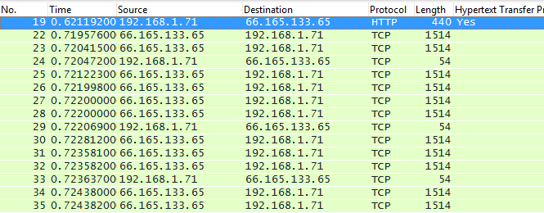

select http file 🡪 right click 🡪 follow TCP Stream

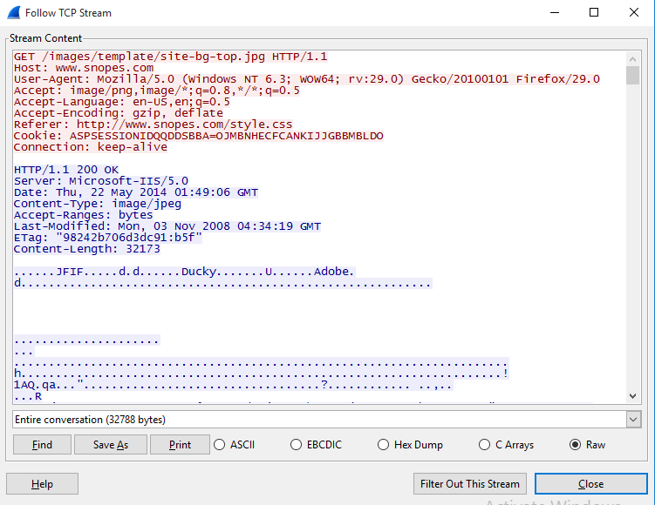

**About what cell phone problem is the client concerned?**

Client talking about cell so we search for cell keyword in whole packets.

frame.matches “(?i)cell

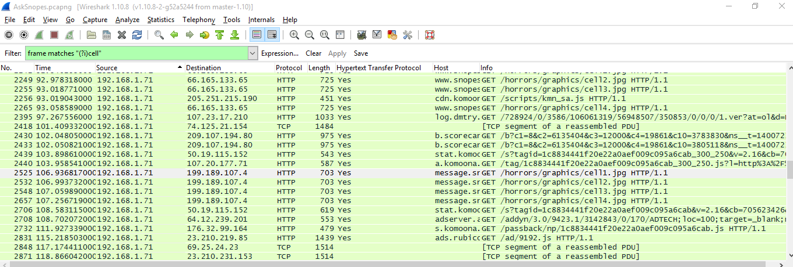

In the first HTTP request cell keyword is in URL and it was about cell phone charging issue.

**According to Zillow, what instrument will Ryan learn to play?**

frame.matches “(?i)zillow”

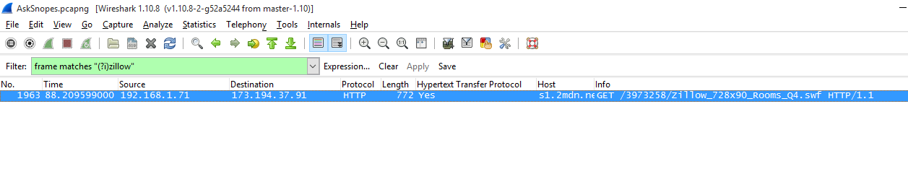

Open file 🡪 Export Object 🡪 HTTP 🡪 save All 🡪 select the folder to save

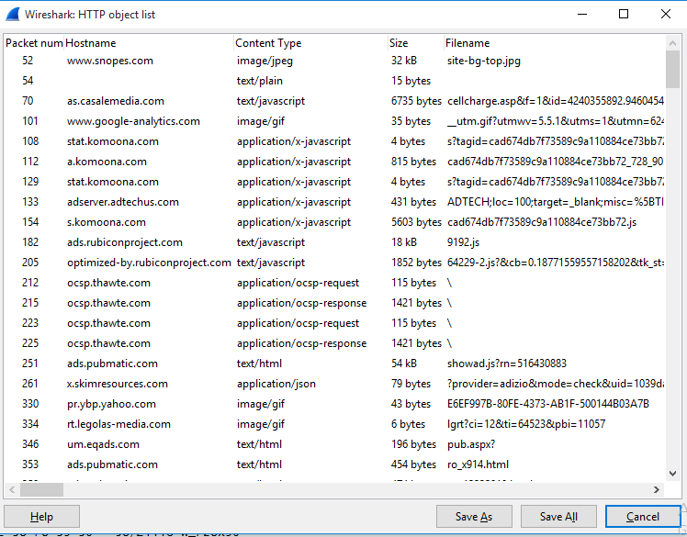

Open the folder 🡪 search for the file name zillow 🡪 open with browser



**How many web servers are running Apache?**

http.response

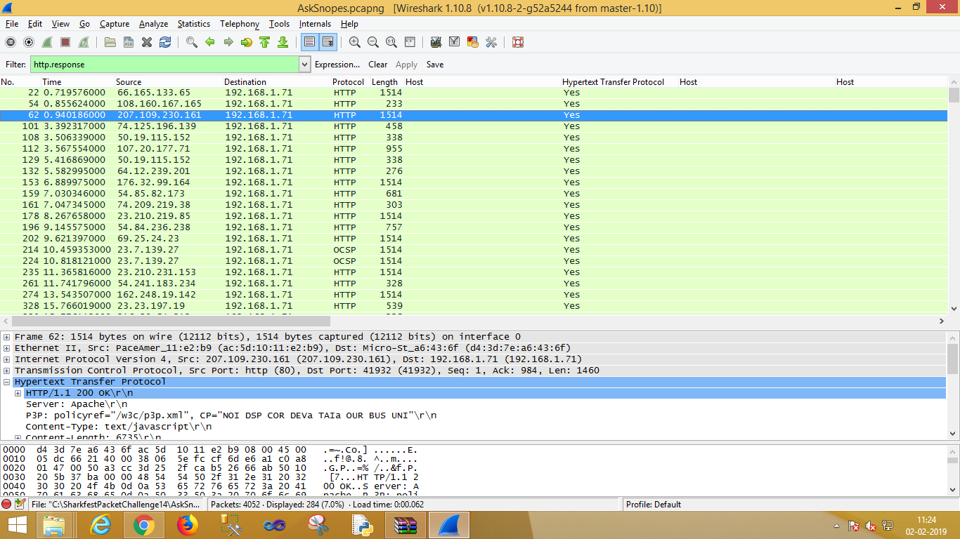

Select http 🡪 apply as column

http.server contains “Apache”

